Court Queens Bench Of Alberta

No Trespassing – Get out Thugs
Or Police Will
Arrest On Warrant

BitcoinInvestor & Global TV Entertainment Affiliate Which Is
100% Stock Trade Profit Funds From a Professional MoneyMake Trading System.

Never Put A hold On These Funds - Visit for Proof of Funds:
https://bitcoin-Investor.ca

Admin1 Task: Finish Document and send to legal shield head office

Plaintive:

Defendant/ Accused:

Barrister Solicitor/ Law Firm:
Peter R J Royal & Darryl Royer
& Legal Shield
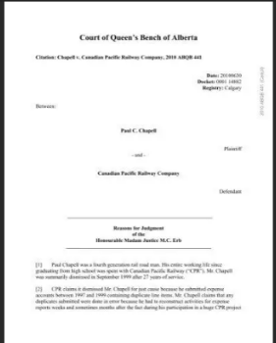

Barrister Solicitor
Lawyers/ Attorneys: Peter Royal & Darryl Royer
Legal Shield

